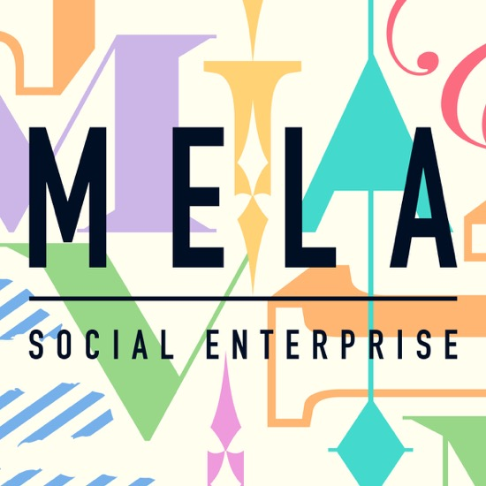
MELA Social Enterprise
Announce
for Emerging and/or diverse artists
To be presented at
Big Heart Balsall Heath
intercultural community event on 8th October 2017 along the Moseley Road
Commission £1000
Funded by Arts Council England
Deadline for Applications 25 August 2017

We want artists to propose artistic activity that gets the diverse community of Balsall Heath talking to one another on a day involving over 12 community organisations. We invite artists:
· To propose an intervention at a diverse community event.
· To experiment, do something different, collaborate
and take risks with their practice.

To support artists to understand the context and improve access to the proposal making process, we have organised a gathering for artists and community organisations on Monday August 14 2017 at 4pm - 7 pm at Moseley School of Art, 496 Moseley Road, Birmingham, B12 9AH.
The gathering at Moseley School of Art is an opportunity:
· To say a few words and present a sample of your work.
· To visit spaces where you will propose work.
· To meet organisations, and find out what they are planning.
· It’s a safe space to inspire creative thinking about what you might do in a unique social context.

If you wish to attend Big Heart Balsall Heath gathering please email: artistalanmclean44@gmail.com
You can find Big Heart Balsall Heath on eventbrite and book your place.
Commissioning brief for applying emerging and/or diverse artists
Mela social enterprise want to research the role of ‘place’ in meeting the social and cultural needs of diverse communities and their identities. MELA aim to bring the diverse communities of Balsall Heath together and make the Moseley Road a new meeting place for the neighbourhood. This project is open to all art forms and will commission artists to produce new work to inspire the local community of Balsall Heath to participate in a unique market day; that will transform the Moseley Road, and bring about lasting dialogue between cultures and facilitate collaboration between community organisations.
When making their proposal, we ask emerging artists to consider this context of a community “happening” along the Moseley road where organisations have created their own stalls and participatory activity because we are asking community organisations to express their market stall in a number of ways.
Some ideas are:
Trading: an opportunity for local makers, producers and businesses to showcase their goods
Performing: an opportunity for the development of local cultural and creative talent across Balsall Heath working in spoken word, music, visual arts, dance, craft, decorative arts, mehndii etc.
Sharing: an opportunity to engage in conversations and learn about what’s going on in Balsall Heath
Learning: an opportunity to take part in a series of workshops to learn from those living and working in Balsall Heath
Eating: an opportunity to taste the various cultural cuisines of people living and working in Balsall Heath
Mela are interested in new approaches to social cohesion, and seek to find ways to bridge communities and bring about intercultural activity in the public realm. We offer a social context for new work, and welcome interdisciplinary practice and collaboration.
· We will accept proposals from emerging artists based in Birmingham and surrounding areas.
· On this project we are interested in working with artists that identify themselves as diverse and emerging.
· We ask emerging artists to make proposals that engage audiences in a different way.
· We anticipate thematic and topical proposal’s to get people talking.
· We welcome, culturally diverse art forms, urban art, music, song writing, dance, heritage / site-specific themes, spoken word, digital interactive art, artist walks, visual art, installation, sensory art-work, live art, music, sound art.
· We anticipate artists interventions, please provide an explanation of how you will involve visitors and audiences using Birmingham and Balsall Heath as a melting pot for diversity, and as the site and location of your work.
· If you are a disabled artist or Deaf artist you can apply for an additional £500 to support you to manage your project.
Contact MELA Social Enterprise
Dr Noha Nasser: melasocialenterprise@gmail.com
Alan McLean email: artistalanmclean@gmail.com
Alan McLean Mobile/text: 07982 237163

MELA Social Enterprise Proposal Form
Commissions for Emerging and/or Diverse artists

Name
Address
Email
Contact Number
Proposal
Maximum 1000 words
Biography
Maximum 500 words
How do you define term emerging artist and your fit with this term?
How do you define term diversity and your fit with this term?
If you identify as a disabled artist or Deaf please tell us support you require to manage your project ?
If you are using another format to make your proposal, eg video, please provide on line link ?
Website or online profile, If any?
Please tell us about arts organisations or projects, or individuals that have supported your work in the past?
Any more information you wish to add?

Return form by Monday August 25th 2017
email: melasocialenterprise@gmail.com

